|  |
| --- |
|  |

Smart Dining Based on Restaurant Occupancy

Vivek Narayanamurthy |

Sriram Vamsi Ilapakurthy

 EECS 221: Internet of Things

15th June 15, 2017

Contents

1. Motivation 2

2. Why is it an attractive product? 2

1.1 Restaurant Owners 2

2.1 Hungry Customers 2

3. Product marketing 2

4. System Architecture 4

5. Sensing & controlling technology 4

5.1 Controller 4

5.2 BiDirectional People counter 4

5.3 REAL-time performance 5

6. Connectivity and Communication. 5

6.1 Local gateway 5

6.2 Cloud Server 5

7. Smart technology including data analytics, sensing fusion, machine learning 6

7.1 Data processing. 6

7.2 Machine learning Algorithm 6

7.3 Leveraging live data with learning for predictions 6

8. End-user Interface 6

9. QoS, including security, privacy, real-time, stability, manageability 6

9.1 Security 6

9.2 Privacy 7

9.3 Stable, QoS and Manageability 7

10. Market survey 7

11. Estimated Cost of the Product 8

# Motivation

People go to restaurants to have good food and to spend quality time with their loved ones. Oftentimes this doesn’t turn out to be great due to many factors. One of the reasons for this is that most of the restaurants are overcrowded and there are often serpentine queues for getting a table. To add to this the service is a crowded restaurant is often terrible. Some orders are never placed and some orders take an eternity to be served. There can also be a crisis of running out of ingredients for dishes. This is mainly due to the understaffed workforce and poor planning. As a result of this, the customer experience is bad, the reputation of the restaurant plummets and a lot of food is wasted. .

With the emergence of IoT based sensors and networks, the above problem can be easily solved. A simple people counter placed at the entrance of a restaurant can help in monitoring the complex flow of people in to the restaurant. A large set of this data can be leveraged to find patterns in the people flow to the restaurant and can solve all the problems. Therefore a cloud based app can help both the customers as well as the restaurant owners.

# Why is it an attractive product?

There are primarily two stakeholders for the product.

## Restaurant Owners

By using the Smart Dining app, the restaurant owners can better manage their business and customers.

* Improved Customer Satisfaction
* Increased Revenue
* Reduced Workforce.
* Better Inventory Management

## Hungry Customers

Any restaurant goer can benefit from using the cloud app. The following are the advantages.

* A lot of time is saved.
* Good service from the restaurant.

# Product marketing

The product is primarily targeted for use by the restaurant owners. The following is a marketing flyer targeting them.

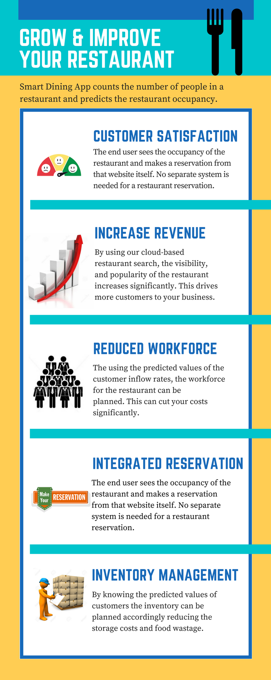

# System Architecture

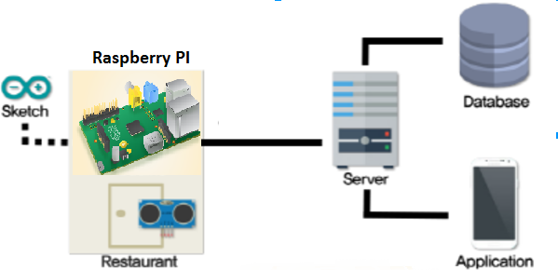

Figure 1: System Architecture

In this systems, every restaurant has a Raspberry Pi which senses the number of people within the restaurant and periodically sent to the cloud service. The data is persisted to a database and learning algorithms are periodically executed on the data to make predictions.

# Sensing & controlling technology

## Controller

We chose to use Raspberry Pi 3 as the IoT end device controller. This is primarily because the Smart Dining App needs to continuously collect data from the sensors and securely upload the counting data to a cloud based service like AWS. The Raspberry Pi’s inbuilt Wi-Fi capability and Linux kernel is very helpful for this application.

## BiDirectional People counter

A single ultrasonic sensor can be used for detecting the movement of a person. By placing two sets of ultrasonic sensors at a distance from each other, the direction of the motion can be accessed.

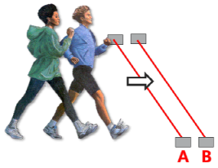

Figure 2: People sensing and determining direction.

The following elaborates the exact mechanism. In the above diagram, when Sensor A detects the presence and then sensor B detects the presence, the person is moving into the restaurant. Likewise, when the sensor B detects the first presence and then sensor A detects the presence, the person is moving out of the restaurant.

## REAL-time performance

The sensing happens in real time as people cross between the two sensors. The exact people count is maintained locally and is sent to the cloud every two minutes.

# Connectivity and Communication.

For this particular application in a restaurant scenario, the connection between two IoT devices is not needed. All the devices can talk to the gateway directly.

## Local gateway

Most of the restaurants have an inbuilt Wi-Fi within the restaurant therefore all the Arduino devices can directly. The restaurant's router itself is the local gateway.

## Cloud Server

All the data from the Raspberry PI is uploaded to AWS through MQTT protocol and is stored the data in the Amazon’s DynamoDB. The machine learning algorithms are run on the AWS servers and predictions are made based on the historical data in the database.

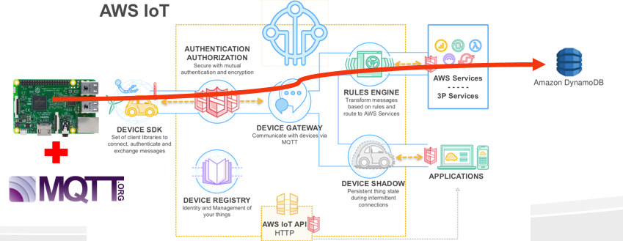

Figure 3 : Dataflow and communication from sensors through the AWS IoT cloud

# Smart technology including data analytics, sensing fusion, machine learning

With the availability of huge occupancy data, it is possible to further analyze them using machine learning and predict the occupancy in the future. It is also possible to plot it over a period of time as a useful analytics for the restaurant management.

The restaurant occupancy history, weather, day and time of the week act as features for modeling the system using machine learning. Live weather data such as temperature and humidity of the city can be obtained from the internet.

Through the data, we would like to answer, following questions for the restaurant users.

* Which day of the week is it typically best to go to my favorite restaurant?
* Which hour of the day is best?
* If I like more than one restaurant, which one is likely to have less crowded?

To predict how crowded the restaurant is going to be in the future, the percentage of total occupancy of the restaurant that is currently occupied as our metric. The occupancy history acts as a labeled training data. It is a continuous value hence falls under a supervised learning regression problem.

We are planning to use scikit-learn library in Python for machine learning. We are planning to try linear regression, random forest, and shrinkage algorithms and decide the better algorithm based on the cross validation test results.

## Data processing.

## Machine learning Algorithm

## using live data with learning for enhanced predictions

# End-user Interface

When a user opens the application on web, he/she can search for the occupancy of a restaurant. The UI displays the restaurant and its corresponding occupancy. The display shows the

# QoS, including security, privacy, real-time, stability, manageability

## Security

The communications between the device and the gateway (router) happens though Wi-Fi which is very secure. A standard hard case should be used to physically secure the device from hacking or tapping. Other than this, the gateway (Wi-Fi router) and standard web protocols are very secure.

## Privacy

In this the IoT device is just counting the number of users who entered and exited the restaurant, we are not associating the identity of the customers for this application. Therefore there are no privacy concerns for this solution.

## 9.3 Stable, QoS and Manageability

The end IoT device has very little code and is very stable. As long as the restaurant has a stable Wi-Fi connectivity, the QoS should be very good. The IoT device is deployed within the premises of the restaurant hence they can be directly hooked to the mains supply instead of batteries. The ultrasonic sensors are very rugged and not easily affected by the external environment. Therefore they systems doesn’t require any end user maintenance once installed.

# Market survey

**Google Places or Local Guides** is the only competitor for this product, the occupancy data can be freely accessed by anyone. Google predicts the occupancy of public places by anonymously tracking people’s GPS location. It only considers the data collected from people who have accepted to be tracked. Hence the predictions by Google are based on a limit set of users and may not truly reflect the actual demand and occupancy of the restaurant.

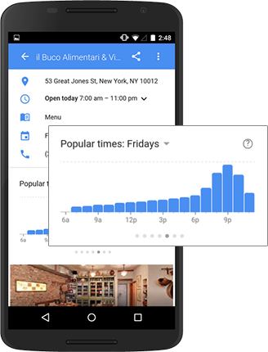

Figure 4: Google’s popular times showing occupancy at different times.

# Estimated Cost of the Product

|  |  |  |
| --- | --- | --- |
| **S. No** | **Item** | **Cost** |
| 1 | Raspberry Pi | $30 |
| 2 | Ultrasonic Sensors | $3 x 2 |
| 3 | Display | $5 |
| 4 | Enclosed box | $10 |
| 5 | Cloud charges (Data storage and learning) | $5 Per month |
| 6 | Software Licensing | $0 (Open Source) |
|  | **Total** | **$56** |

# Product Demo

## Video Demo

## Website

* 1. Slides

# References